Prototype:  Screen 1  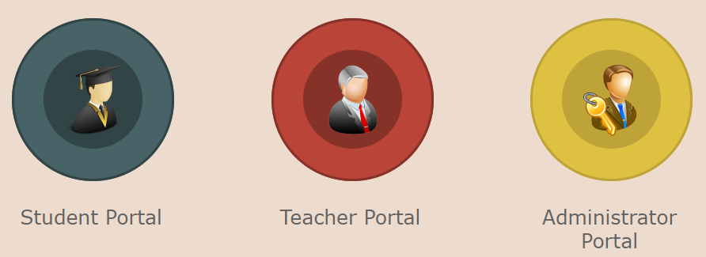  Screen 2  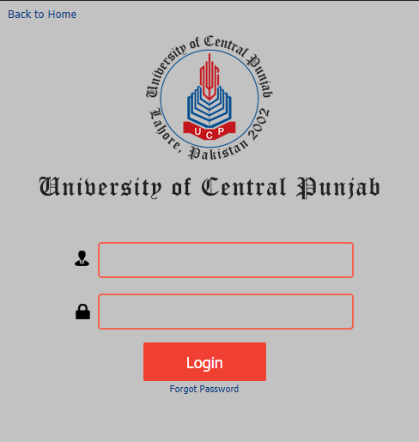 | The users: | We will assume that the user is familiar with login process.
 | Task Description: | A teacher wants to login in their account using username and password.
Actions:

UA 1: Click on “Teacher Portal” button.
SD 1: Screen 2 appears.

UA 2: Enter user name.
SD 2: Each letter is displayed as typed.

UA 3: Enter password
SD 3: An asterisk is shown against each typed digit

UA 4: Click on “Login” button
SD 4a: Main screen is displayed on successful login.
SD 4b: User remains on screen 2 and an error message is displayed.

(UA = User Action, SD = System Display)

Cognitive walkthrough UA1
Question 1: Will users see that the action is available?
Question 2: Once users have found the correct action, will they know it is the one they need?
Question 3: Is the effect of the action the same as the user’s goal at that point?
Question 4: After the action is taken, will users understand the feedback they get?

